**DAILY ONLINE ACTIVITIES SUMMARY**

|  |  |  |  |  |  |  |  |  |
| --- | --- | --- | --- | --- | --- | --- | --- | --- |
| **Date:** | **02-06-2020** | | | | | **Name:** | **Poojashree T** | |
| **Sem & Sec** | **8th sem B sec** | | | | | **USN:** | **4al16cs064** | |
| **Online Test Summary** | | | | | | | | |
| **Subject** | |  | | | | | | |
| **Max. Marks** | |  | | **Score** | | |  | |
| **Certification Course Summary** | | | | | | | | |
| **Course** | **R language tutorial** | | | | | | | |
| **Certificate Provider** | | | **Great learning academy** | | **Duration** | | | **3.0hr** |
| **Coding Challenges** | | | | | | | | |
| **Problem Statement:** **1**. **to read the number and compute the series.**  **2. to count the number in th series.**  **3. to check whether number is palindrome or not.**  **4. to find the number between 0 and 50 which are not divisible by 2 and 3.**  **5.micro and array update**  Top of Form | | | | | | | | |
| **Status:completed** | | | | | | | | |
| **Uploaded the report in Github** | | | | | **yes** | | | |
| **If yes Repository name** | | | | | **Poojashree T** | | | |
| **Uploaded the report in slack** | | | | | **yes** | | | |

**Online Test**

No Test

Certification course on RPA

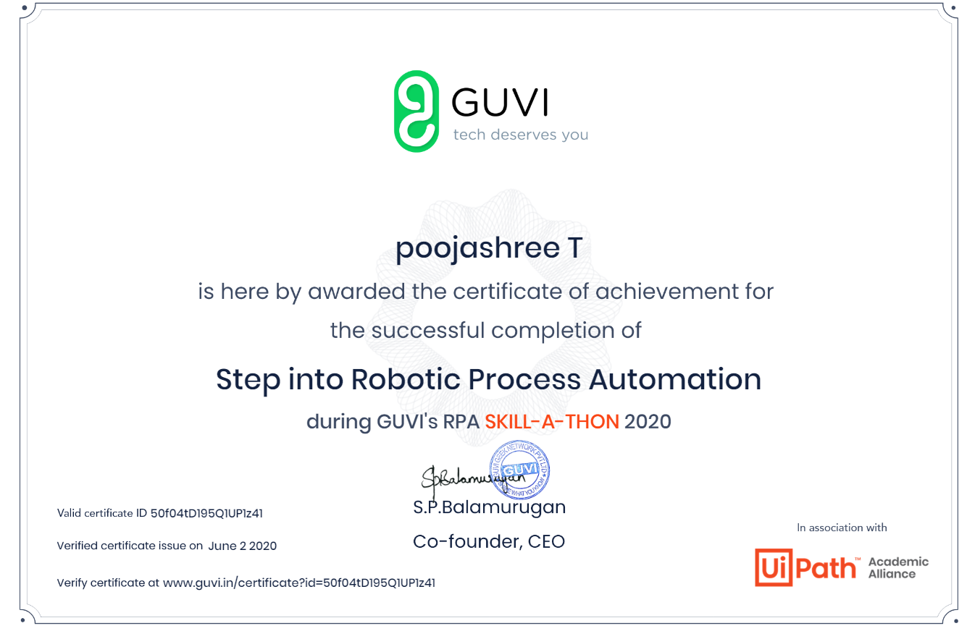

Coding

Bottom of Form

Top of Form

Bottom of Form

class Solution

{

public int reverse(int x)

{

int rev=0,rem=0,prev_rev=0;

while(x!=0){

rem=x%10;

rev=(rev*10)+rem;

x=x/10;

if((rem-rev)/10 !=prev_rev)

{

return 0;

}

prev_rev=rev;

}

return rev;

}

}